JAVA RECORD
WEEK-1:
(i) AIM: Accept two strings from the user and print them on the console with concatenation of “and” in the middle of the strings.
PROGRAM:
Using the Scanner class method:
import java.util.Scanner;
public class Week1a {
public static void main(String args[]) {
Scanner sc = new Scanner(System.in);
String s1, s2;
System.out.print("Enter the first string: ");
s1 = sc.next();
System.out.print("Enter the second string: ");
s2 = sc.next();
System.out.print(s1+" and "+s2);
sc.close();
}
}

Output:

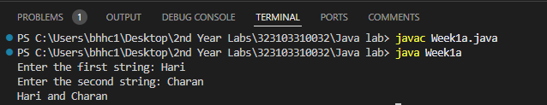

Using Command line arguments:
public class Week1b {
public Week1b() {
}
public static void main(String[] var0) {
String var1 = var0[0];
String var2 = var0[1];
System.out.println(var1 + " and " + var2);
}
}
Output:

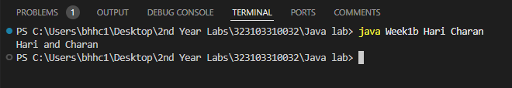

(ii)AIM: To find the perimeter and area of a circle given the value of
radius.
PROGRAM:
import java.util.Scanner;
public class Week1c {
public static void main(String args[]) {
Scanner sc = new Scanner(System.in);
double a, p, r;
System.out.print("Enter the radius: ");
r = sc.nextDouble();
a = (3.14) * (r) * (r);
p = (2) * (3.14) * (r);
System.out.println("The area is " + a);
System.out.println("The perimeter is " + p);
}
}
Output:

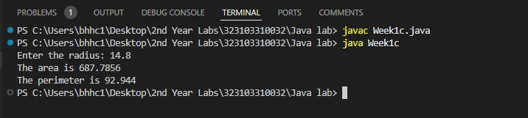

WEEK-2:
(a)AIM: Program to call default constructor first and then any other
constructor in the class.
PROGRAM:
class Rectangle {
double length, breadth;
Rectangle() {
length = 1.25;
breadth = 4.05;
}
Rectangle(double length, double breadth) {
this.length = length;
this.breadth = breadth;
}
double Area() {
return length * breadth;
}
}
class Week2a {
public static void main(String[] args) {
Rectangle r1 = new Rectangle();
Rectangle r2 = new Rectangle(2.54, 4);
System.out.println("Area of rectangle 1: " + r1.Area());
System.out.println("Area of rectangle 2: " + r2.Area());
}
}

Output:

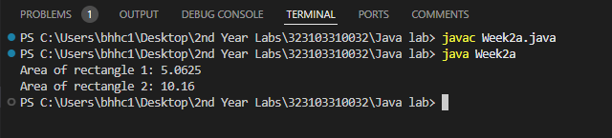

(B) AIM: Program that accepts an array of integers and print those
which are both odd and prime. If no such element is in that array print
“Not found”.
PROGRAM:
import java.util.Scanner;
public class Week2b {
public static void main(String[] args) {
Scanner sc = new Scanner(System.in);
System.out.print("Enter the no of elements: ");
int n = sc.nextInt();
int[] a = new int[n];
int count = 0, flag = 0;
System.out.print("Enter the array elements: ");
for (int i = 0; i < n; i++) {
a[i] = sc.nextInt();
}
for (int i = 0; i < n; i++) {
for (int j = 1; j <= a[i]; j++) {
if (a[i] % j == 0) {
count++;
}
}
if (count == 2 && a[i] % 2 == 1) {
System.out.print(a[i] + " ");
flag++;
}
count = 0;
}
if (flag == 0) {
System.out.print("Not Found");
}
sc.close();
}
}

Output:

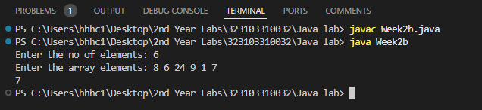

(C) AIM: Program to accept contents into an Integer Array and print
the frequency of each number in the order of their number of
occurrences.
PROGRAM:
import java.util.Scanner;
public class Week2c {
public static void main(String args[]) {
Scanner sc = new Scanner(System.in);
System.out.print("Enter the size of array: ");
int n = sc.nextInt();
int a[] = new int[n];
System.out.println("Enter the elements: ");
for(int i=0; i<n; i++) {
a[i] = sc.nextInt();
}
for(int i=0; i<n; i++) {
int count=1,temp=a[i];
for(int j=i+1; j<n; j++) {
if(a[j]==temp) {
count++;
n--;
for(int k=j; k<n; k++) {
a[k] = a[k+1];
}
j--;
}
}
System.out.println(temp+" is repeated "+count+" times");
}
for(int i=0; i<n; i++) {
System.out.print(a[i]+" ");
}
sc.close();
}
}

Output:

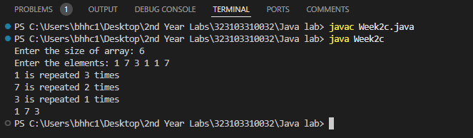
(D) AIM: Program that accepts an “m x n‟ double dimension array,
where “m‟ represents financial years and “n‟ represents Ids of the
items sold. Each element in the array represents number of items
sold in a particular year. Identify the year and id of the item which
has more demand.
PROGRAM:
import java.util.Scanner;
class Week2d {
public static void main(String arg[]) {
int m, n, i, j, fy = 0, pid = 0, max;
Scanner sc = new Scanner(System.in);
System.out.print("Enter the No of Financial Years: ");
m = sc.nextInt();
System.out.print("Enter the no of Products: ");
n = sc.nextInt();
int sales[][] = new int[m + 1][n + 1];
System.out.println("Enter Financial Years");
for (i = 0; i < m; i++) {
sales[i + 1][0] = sc.nextInt();
}
System.out.println("Enter product IDs");
for (j = 0; j < n; j++) {
sales[0][j + 1] = sc.nextInt();
}
for (i = 1; i <= m; i++) {
System.out.println("Enter no.of sales in " + sales[i][0] + " Fin.Year");
for (j = 1; j <= n; j++) {
sales[i][j] = sc.nextInt();
}
}
System.out.print("*No.of sales in all Years*\n");
for (i = 0; i <= m; i++) {
for (j = 0; j <= n; j++) {
System.out.print(sales[i][j] + " ");
}
System.out.println();
}
max = sales[1][1];
for (i = 1; i <= m; i++) {
for (j = 1; j <= n; j++) {
if (sales[i][j] > max) {
max = sales[i][j];
fy = sales[i][0];
pid = sales[0][j];
}
}
}
System.out.println("The Product ID " + pid + " has the maximum sales in the Financial Year " + fy);
sc.close();
}
}

Output:
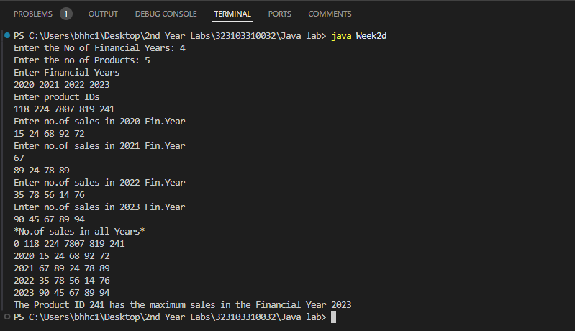

WEEK-3
(A) AIM: Create a class Box that uses a parameterized constructor to
initialize the dimensions of a box. The dimensions of the Box are
width, height, depth. The class should have a method that can return
the volume of the box. Create an object of the Box class and test the
functionalities.
Program:
class Box {
double width, height, depth;
Box(double width, double height, double depth) {
this.width = width;
this.height = height;
this.depth = depth;
}
double getVolume() {
return width * height * depth;
}
}
class Week3a {
public static void main(String[] args) {
Box b1 = new Box(1.4, 2.25, 1.25);
double x = b1.getVolume();
System.out.println("Volume of the Box is" + " " + x);
}
}

Output:
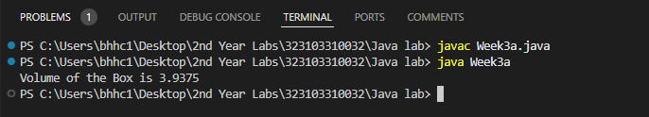

(B)AIM: Create a new class called Calculator with the following
methods: A static method called powerInt(int num1,int num2) This
method should return num1 to the power num2. A static method
called powerDouble(double num1,double num2). This method
should return num1 to the power num2. Invoke both the methods
and test the functionality. Also count the number of objects created
Program:
class Week3b {
public static int powerInt(int num1, int num2) {
return (int) Math.pow(num1, num2);
}
public static double powerDouble(double num1, double num2) {
return Math.pow(num1, num2);
}
public static void main(String[] args) {
System.out.println("Output using powerInt method: " + powerInt(25, 3));
System.out.println("Output using powerDouble method: " + powerDouble(2.4, 3));
}
}
Output:

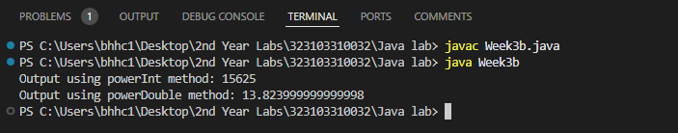

WEEK-4
(A) AIM: Accept a String and a number “n” from the user. Divide the given
string into substrings each of size “n” and sort them lexicographically
PROGRAM:
import java.util.Scanner;
import java.util.Arrays;
public class Week4a {
public static void main(String args[]) {
Scanner sc = new Scanner(System.in);
String s1;
int n;
int count = 0;
System.out.print("Enter the string: ");
s1 = sc.next();
System.out.print("Enter the number of letters you want in substring: ");
n = sc.nextInt();
System.out.println("The substrings containing " + n + " letters each are: ");
for (int i = 0; i < (s1.length() / n) + 1; i++) {
StringBuffer s2 = new StringBuffer();
for (int j = 0; j < n && count < s1.length(); j++) {
s2.append(s1.charAt(count));
count++;
}
String s3 = s2.toString();
char arr[] = s3.toCharArray();
Arrays.sort(arr);
String s4 = new String(arr);
System.out.println(s4);
}
sc.close();
}
}

Output:
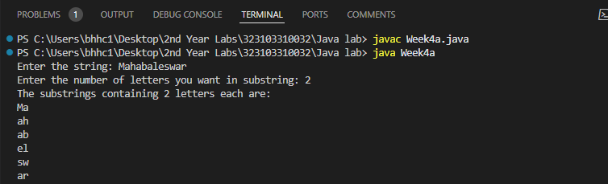
(B) AIM: Accept an array of strings and display the number of vowels
and consonants occurred in each string.
PROGRAM:
import java.util.Scanner;
class Week4b {
public static void main(String args[]) {
Scanner sc = new Scanner(System.in);
int n;
System.out.print("Enter no of Strings: ");
n = sc.nextInt();
String str[] = new String[n];
System.out.print("Enter Strings: ");
for (int i = 0; i < n; i++) {
str[i] = sc.next();
}
for (int i = 0; i < n; i++) {
int vow = 0;
int cons = 0;
for (int j = 0; j < str[i].length(); j++) {
char ch = str[i].charAt(j);
if (ch == 'a' || ch == 'e' || ch == 'i' || ch == 'o' || ch == 'u') {
vow++;
} else {
cons++;
}
}
System.out.println("Vowel count in " + str[i] + " is " + vow);
System.out.println("Consonant count in " + str[i] + " is " + cons);
}
}
}

Output:
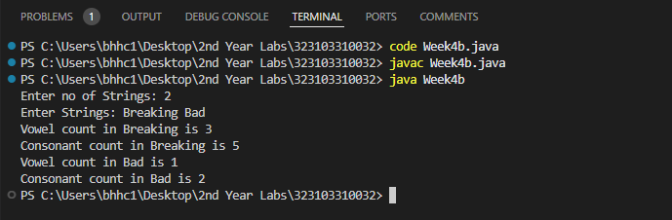

(C) AIM: Accept two strings from the user and determine if the strings
are anagrams or not.
PROGRAM:
import java.util.*;
public class Week4c {
public static void main(String args[]) {
String s1 = new String();
String s2 = new String();
Scanner sc = new Scanner(System.in);
System.out.print("Enter the first string: ");
s1 = sc.next();
System.out.print("Enter the second string: ");
s2 = sc.next();
if (s1.length() == s2.length()) {
char s1ar[] = s1.toCharArray();
char s2ar[] = s2.toCharArray();
Arrays.sort(s1ar);
Arrays.sort(s2ar);
int count = 0;
for (int i = 0; i < s1.length(); i++) {
if (s1ar[i] == s2ar[i]) {
count++;
}
}
if (count == s1.length()) {
System.out.println("The strings are anagrams");
} else {
System.out.println("The strings are not anagrams");
}
} else {
System.out.println("The strings are not anagrams");
}
}
}

Output:
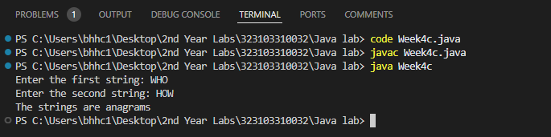

WEEK-5
(A) AIM: Create a multilevel inheritance for classes vehicle, brand and
cost. The vehicle class determines the type of vehicle which is
inherited by the class brand which determines the brand of the
vehicle. Brand class is inherited by cost class, which tells about the
cost of the vehicle. Create another class which calls the constructor
of cost class and method that displays the total vehicle information
from the attributes available in the super classes.
PROGRAM:
class Vehicle{
String type;
Vehicle(String type){
this.type = type;
}
}
class Brand extends Vehicle{
String brand;
Brand(String type, String brand){
super(type);
this.brand = brand;
}
}
class Cost extends Brand{
int cost;
Cost(String type, String brand, int cost){
super(type, brand);
this.cost = cost;
}
void display(){
System.out.println("Type: "+type);
System.out.println("Brand: "+brand);
System.out.println("Cost: "+cost);
}
}
public class Week5a {
public static void main(String[] args) {
Cost c1 = new Cost("Sidan", "BMW", 5000000);
c1.display();
}
}

Output:
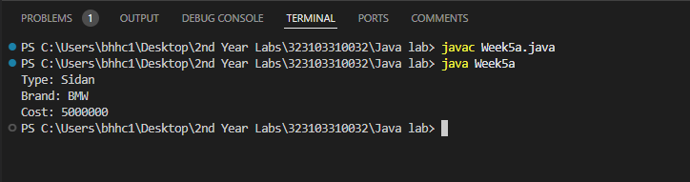

(B) AIM: Create an inheritance hierarchy of Figure_3D, Cylinder, Cone,
Sphere etc. In the base class provides methods that are common to
all Figure_3Ds and override these in the derived classes to perform
different behaviors, depending on the specific type of Figure_3D.
Create an array of Figure_3D, fill it with different specific types of
Figure_3Ds and call your base class methods.
PROGRAM:
class Figure_3d {
String figure;
Figure_3d(String figure) {
this.figure = figure;
}
void volume() {
return;
}
}
class Cylinder extends Figure_3d {
double height;
double radius;
Cylinder(String figure, double height, double radius) {
super(figure);
this.height = height;
this.radius = radius;
}
@Override
void volume() {
System.out.println("The shape of the 3d-figure is: " + super.figure);
double volume = (3.14) * radius * radius * height;
System.out.println("The volume of the cylinder is " + volume);
}
}
class Cone extends Figure_3d {
double height;
double radius;
Cone(String figure, double height, double radius) {
super(figure);
this.height = height;
this.radius = radius;
}
@Override
void volume() {
System.out.println("The shape of the 3d-figure is: " + figure);
double volume = (3.14) * radius * radius * (height / 3);
System.out.println("The volume of the cone is " + volume);
}
}
class Sphere extends Figure_3d {
double radius;
Sphere(String figure, double radius) {
super(figure);
this.radius = radius;
}
@Override
void volume() {
System.out.println("The shape of the 3d-figure is: " + figure);
double volume = (4 / 3.0) * (3.14) * radius * radius * radius;
System.out.println("The volume of the sphere is " + volume);
}
}
public class Week5b {
public static void main(String[] args) {
Figure_3d arr[] = new Figure_3d[3];
Cylinder c1 = new Cylinder("CYLINDER_SHAPE", 7, 5);
arr[0] = c1;
Cone cn1 = new Cone("CONE_SHAPE", 6, 3);
arr[1] = cn1;
Sphere s1 = new Sphere("SPHERE_SHAPE", 5);
arr[2] = s1;
for (int i = 0; i < 3; i++) {
arr[i].volume();
}
}
}

Output:
